SMART PARKING SYSTEM

*What is smart parking*?

In a nutshell, Smart Parking is a parking solution that can include in-ground Smart Parking sensors, cameras or counting sensors. These devices are usually embedded into parking spots or positioned next to them to detect whether parking bays are free or occupied.  This happens through real-time data collection. The data is then transmitted to a smart parking mobile application or website, which communicates the availability to its users. Some companies also offer other in-app information, such as parking prices and locations. This gives you the possibility to explore every parking option available to you.

Smart Parking and its Smart Parking Sensors can be seen as a part of smart cities. These smart cities are cities that are driven by an IT infrastructure and by using this infrastructure, cities can enhance the quality of life and improve economic development for its inhabitants. Becoming a smart city can be a good way to collect historical data in a relatively easy way. By collecting this data, cities can analyze how processes, like parking can be optimized.

As a result of using Smart Parking, people who are looking to find a parking spot will find it in the most efficient way possible and companies or municipalities can optimize their parking territories. It also makes cities more livable, safer and less congested.

## Types of smart parking:

## we will divide smart parking systems into 3 main types:

1. Ground sensor technology
2. Counter technology
3. Overhead sensor or camera-based technology

Why is smart parking system important?

It reduces carbon emissions from vehicles by decreasing the congestion and mobility of the vehicles in search of parking. When the drivers move from one place to another for parking, this enhances the individual environmental footprint.

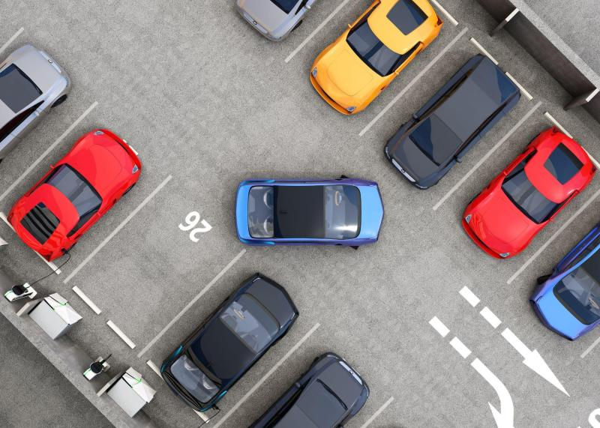

Benefits analysis of Smart Parking Technology:

* Optimized parking.
* Reduced traffic.
* Reduced pollution.
* Enhanced User Experience.
* Integrated Payments and POS.
* Increased Safety.
* Real-Time Data and Trend Insight.
* Decreased Management Costs.

FLOWCHART:

**Update display**

**Increment counter value**

**Going in?**

**Is there a car?**

**Decrement counter value**

**Initializing The Sensors**

NO

YES

NO

ADVANTAGES OF SMART PARKING:

* It helps to reduce traffic congestion by guiding drivers to available parking spots,saving time and fuel.
* It also improves parking management,allowing for better utilization of parking spaces.
* Smart parking can provide real time information on parking availability,making it easier for drivers to find parking quickly.

DISADVANTAGES OF SMART PARKING:

* They require initial investment and maintenance costs,which could be a concern for some.
* Additionally,reliance on technology means that system malfunctions or power outages could disrupt the parking process.
* However ,overall,the benefits of smart parking outweigh these potential drawbacks.

YES